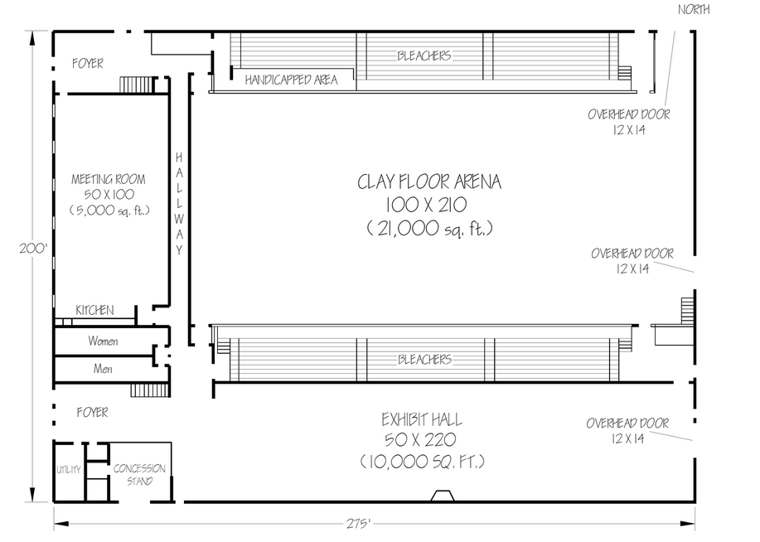

Ring 2

Starters/Adv (USDAA)

Ring 1

Masters (USDAA)

Trailer

Enter/Exit

Enter/Exit

Enter/Exit

Score table

This space is not available

Crating Area, Vendors, Hospitality & Awards